SUBJECT: PHONICS CLASS: K.G

1. Sound orally a-z
2. Identify these sounds
a b c defghijklmnopq
3. Trace these sounds

4. Sound and write a-q
5. a as in ____________________
b as in ___________________
c as in ___________________
d as in ___________________
eas in ___________________
f as in ___________________

6. Match the following sounds to their objects
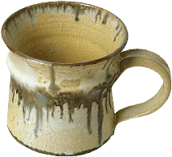

a
b


c
d

